**Test Results**

**Solution: -**

Read all the records from orders.json file and calculate the price of each order by passing coffee name and size in prices.json.

Group all the users and the prices for each user.

Group all the users from payments.json and get all the payment done by each User.

Calculate the due amount (Sum of all Coffee Prices – Payment done by each user).

**Steps to execute the Code :-**

Fetch the code and run ‘npm install’ and then ‘ng serve’.

Comment out the services to get the JSON data manually or host the services.

**Screenshots :-**

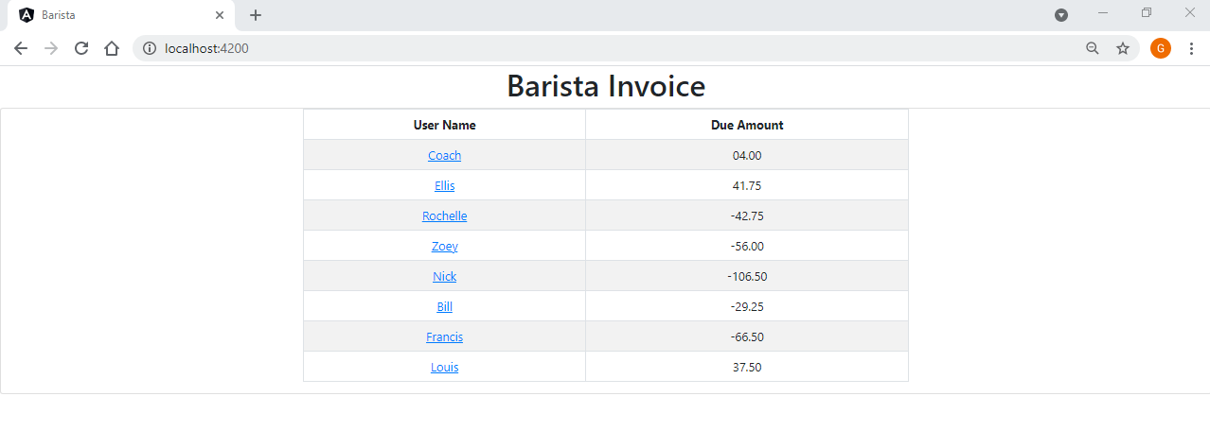

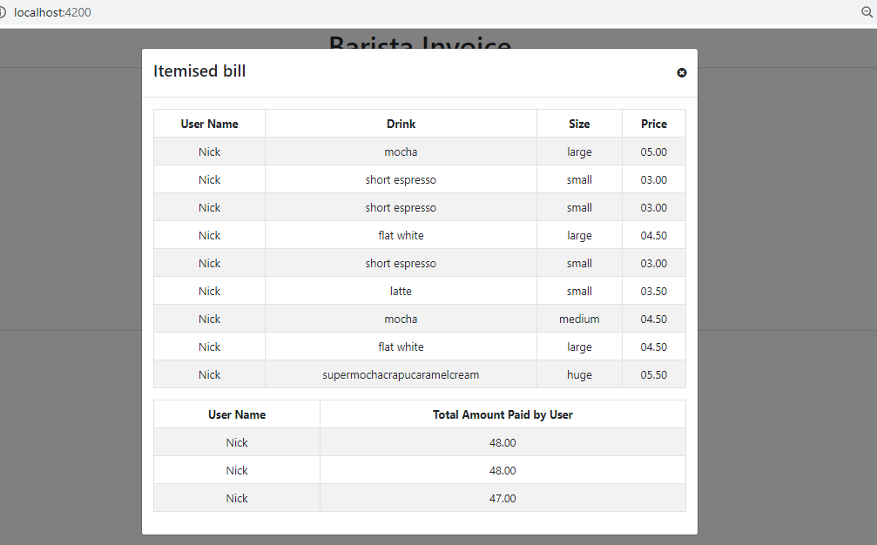

Hosted on Port 9091 by using Spring Boot

